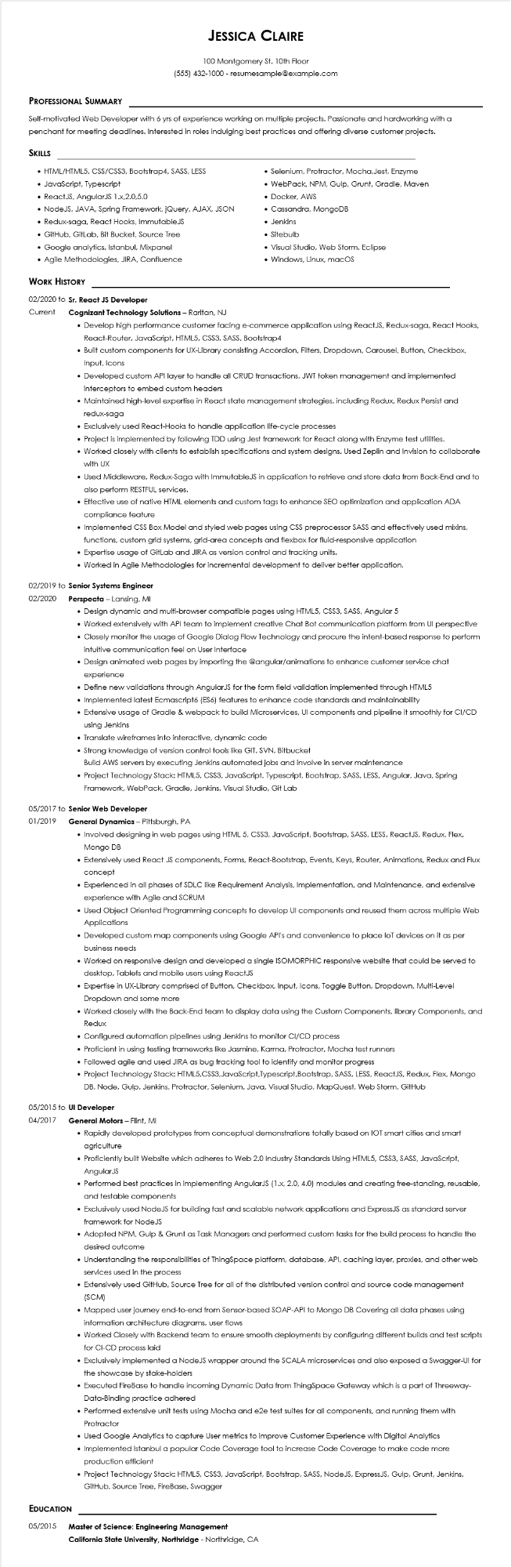
JESSICA CLAIRE
100 Montgomery St. 10th Floor
(555) 432-1000 - resumesample@example.com
PROFESSIONAL SUMMARY
Self-motivated Web Developer with 6 yrs of experience working on multiple projects. Passionate and hardworking with a penchant for meeting deadlines. Interested in roles indulging best practices and offering diverse customer projects.
SKILLS
• HTML/HTML5, CSS/CSS3, Bootstrap4, SASS, LESS
• JavaScript, Typescript
• ReactJS, AngularJS 1.x,2.0,5.0
• NodeJS, JAVA, Spring Framework, jQuery, AJAX, JSON
• Redux-saga, React Hooks, ImmutableJS
• GitHub, GitLab, Bit Bucket, Source Tree
• Google analytics, Istanbul, Mixpanel
• Agile Methodologies, JIRA, Confluence
WORK HISTORY
02/2020 to Sr. React JS Developer
Current
Cognizant Technology Solutions - Raritan, NJ
• Selenium, Protractor, Mocha, Jest, Enzyme
• WebPack, NPM, Gulp, Grunt, Gradle, Maven
• Docker. AWS
• Cassandra, MongoDB
• Jenkins
• Sitebulb
• Visual Studio, Web Storm, Eclipse
• Windows, Linux, macOS
• Develop high performance customer facing e-commerce application using ReactJS, Redux-saga, React Hooks, React-Router, JavaScript, HTML5, CSS3, SASS, Bootstrap4
• Built custom components for UX-Library consisting Accordion, Filters, Dropdown, Carousel, Button, Checkbox, Input, Icons
• Developed custom API layer to handle all CRUD transactions, JWT token management and implemented interceptors to embed custom headers
• Maintained high-level expertise in React state management strategies, including Redux, Redux Persist and redux-saga
• Exclusively used React-Hooks to handle application life-cycle processes
• Project is implemented by following TDD using Jest framework for React along with Enzyme test utilities.
• Worked closely with clients to establish specifications and system designs. Used Zeplin and Invision to collaborate with UX
• Used Middleware, Redux-Saga with ImmutableJS in application to retrieve and store data from Back-End and to also perform RESTFUL services.
• Effective use of native HTML elements and custom tags to enhance SEO optimization and application ADA compliance feature
• Implemented CSS Box Model and styled web pages using CSS preprocessor SASS and effectively used mixins, functions, custom grid systems, grid-area concepts and flexbox for fluid-responsive application
• Expertise usage of GitLab and JIRA as version control and tracking units.
• Worked in Agile Methodologies for incremental development to deliver better application.
02/2019 to Senior Systems Engineer
02/2020
Perspecta - Lansing, MI
• Design dynamic and multi-browser compatible pages using HTML5, CSS3, SASS, Angular 5
• Worked extensively with API team to implement creative Chat Bot communication platform from Ul perspective
• Closely monitor the usage of Google Dialog Flow Technology and procure the intent-based response to perform intuitive communication feel on User Interface
• Design animated web pages by importing the @angular/animations to enhance customer service chat experience
• Define new validations through AngularJS for the form field validation implemented through HTML5
• Implemented latest Ecmascript6 (ES6) features to enhance code standards and maintainability
• Extensive usage of Gradle & webpack to build Microservices, UI components and pipeline it smoothly for CI/CD using Jenkins
• Translate wireframes into interactive, dynamic code
• Strong knowledge of version control tools like GIT, SVN, Bitbucket
Build AWS servers by executing Jenkins automated jobs and involve in server maintenance
• Project Technology Stack: HTML5, CSS3, JavaScript, Typescript, Bootstrap, SASS, LESS, Angular, Java, Spring Framework, WebPack, Gradle, Jenkins, Visual Studio, Git Lab
05/2017 to Senior Web Developer
01/2019
General Dynamics - Pittsburgh, PA
• Involved designing in web pages using HTML 5, CSS3, JavaScript, Bootstrap, SASS, LESS, ReactJS, Redux, Flex, Mongo DB
• Extensively used React JS components, Forms, React-Bootstrap, Events, Keys, Router, Animations, Redux and Flux concept
• Experienced in all phases of SDLC like Requirement Analysis, Implementation, and Maintenance, and extensive experience with Agile and SCRUM
• Used Object Oriented Programming concepts to develop UI components and reused them across multiple Web Applications
• Developed custom map components using Google API's and convenience to place loT devices on it as per business needs
• Worked on responsive design and developed a single ISOMORPHIC responsive website that could be served to desktop, Tablets and mobile users using ReactJS
• Expertise in UX-Library comprised of Button, Checkbox, Input, Icons, Toggle Button, Dropdown, Multi-Level Dropdown and some more
• Worked closely with the Back-End team to display data using the Custom Components, library Components, and Redux
• Configured automation pipelines using Jenkins to monitor CI/CD process
• Proficient in using testing frameworks like Jasmine, Karma, Protractor, Mocha test runners
• Followed agile and used JIRA as bug tracking tool to identify and monitor progress
• Project Technology Stack: HTML5, CSS3, JavaScript, Typescript,Bootstrap, SASS, LESS, ReactJS, Redux, Flex, Mongo DB, Node, Gulp, Jenkins, Protractor, Selenium, Java, Visual Studio, MapQuest, Web Storm, GitHub
05/2015 to UI Developer
04/2017
General Motors - Flint, MI
• Rapidly developed prototypes from conceptual demonstrations totally based on IOT smart cities and smart agriculture
• Proficiently built Website which adheres to Web 2.0 Industry Standards Using HTML5, CSS3, SASS, JavaScript, AngularJS
• Performed best practices in implementing AngularJS (1.x, 2.0, 4.0) modules and creating free-standing, reusable, and testable components
• Exclusively used NodeJS for building fast and scalable network applications and ExpressJS as standard server framework for NodeJS
• Adopted NPM, Gulp & Grunt as Task Managers and performed custom tasks for the build process to handle the desired outcome
• Understanding the responsibilities of ThingSpace platform, database, API, caching layer, proxies, and other web services used in the process
• Extensively used GitHub, Source Tree for all of the distributed version control and source code management (SCM)
• Mapped user journey end-to-end from Sensor-based SOAP-API to Mongo DB Covering all data phases using information architecture diagrams, user flows
• Worked closely with Backend team to ensure smooth deployments by configuring different builds and test scripts for CI-CD process laid
• Exclusively implemented a NodeJS wrapper around the SCALA microservices and also exposed a Swagger-UI for the showcase by stake-holders
• Executed FireBase to handle incoming Dynamic Data from ThingSpace Gateway which is a part of Threeway- Data-Binding practice adhered
• Performed extensive unit tests using Mocha and e2e test suites for all components, and running them with Protractor
• Used Google Analytics to capture User metrics to improve Customer Experience with Digital Analytics
• Implemented Istanbul a popular Code Coverage tool to increase Code Coverage to make code more production efficient
• Project Technology Stack: HTML5, CSS3, JavaScript, Bootstrap, SASS, NodeJS, ExpressJS, Gulp, Grunt, Jenkins, GitHub, Source Tree, FireBase, Swagger
EDUCATION
05/2015
Master of Science: Engineering Management
California State University, Northridge - Northridge, CA

